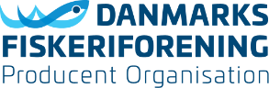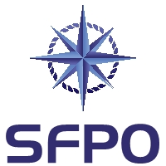

2022-01-21

ICES Secretariat
info@ices.dk

Re. European Eel (Anguilla anguilla)

Danish Fishers PO (DFPO) and Swedish Fishermen PO (SFPO) represent the larger part of the fishers in Denmark and Sweden respectively, including many eel fishers.
In each country we have a long tradition for eel fishing, and we have in recent years done a huge effort to deliver our contribution to a sustainable management of the eel.
We were therefore very surprised to learn the recent changes to the ICES advice on the European Eel:

In the recommendation for 2021 it was said: "ICES advises that when the precautionary approach is applied for European eel, all anthropogenic impacts (e.g. caused by recreational and commercial fishing on all life stages, hydropower, pumping stations, and pollution) that decrease production and escapement of silver eels should be reduced to, or kept as close as possible to, zero in 2021."

In the recommendation for 2022 it is said: "ICES advises that when the precautionary approach is applied, there should be zero catches in all habitats in 2022. This applies to both recreational and commercial catches and includes catches of glass eels for restocking and aquaculture. All other anthropogenic mortalities should be minimized and eliminated where possible."

This gives raise to one basic question that we do hope you will be so kind to answer:
What is the new scientific basis for the amended advice on fishing opportunities recommending a total ban on all eel fishing?

Best regards

Svend-Erik Andersen Peter Ronelöv Olsson
Chairman DFPO Chairman SFPO
www.fiskeriforening.dk www.sfpo.se

